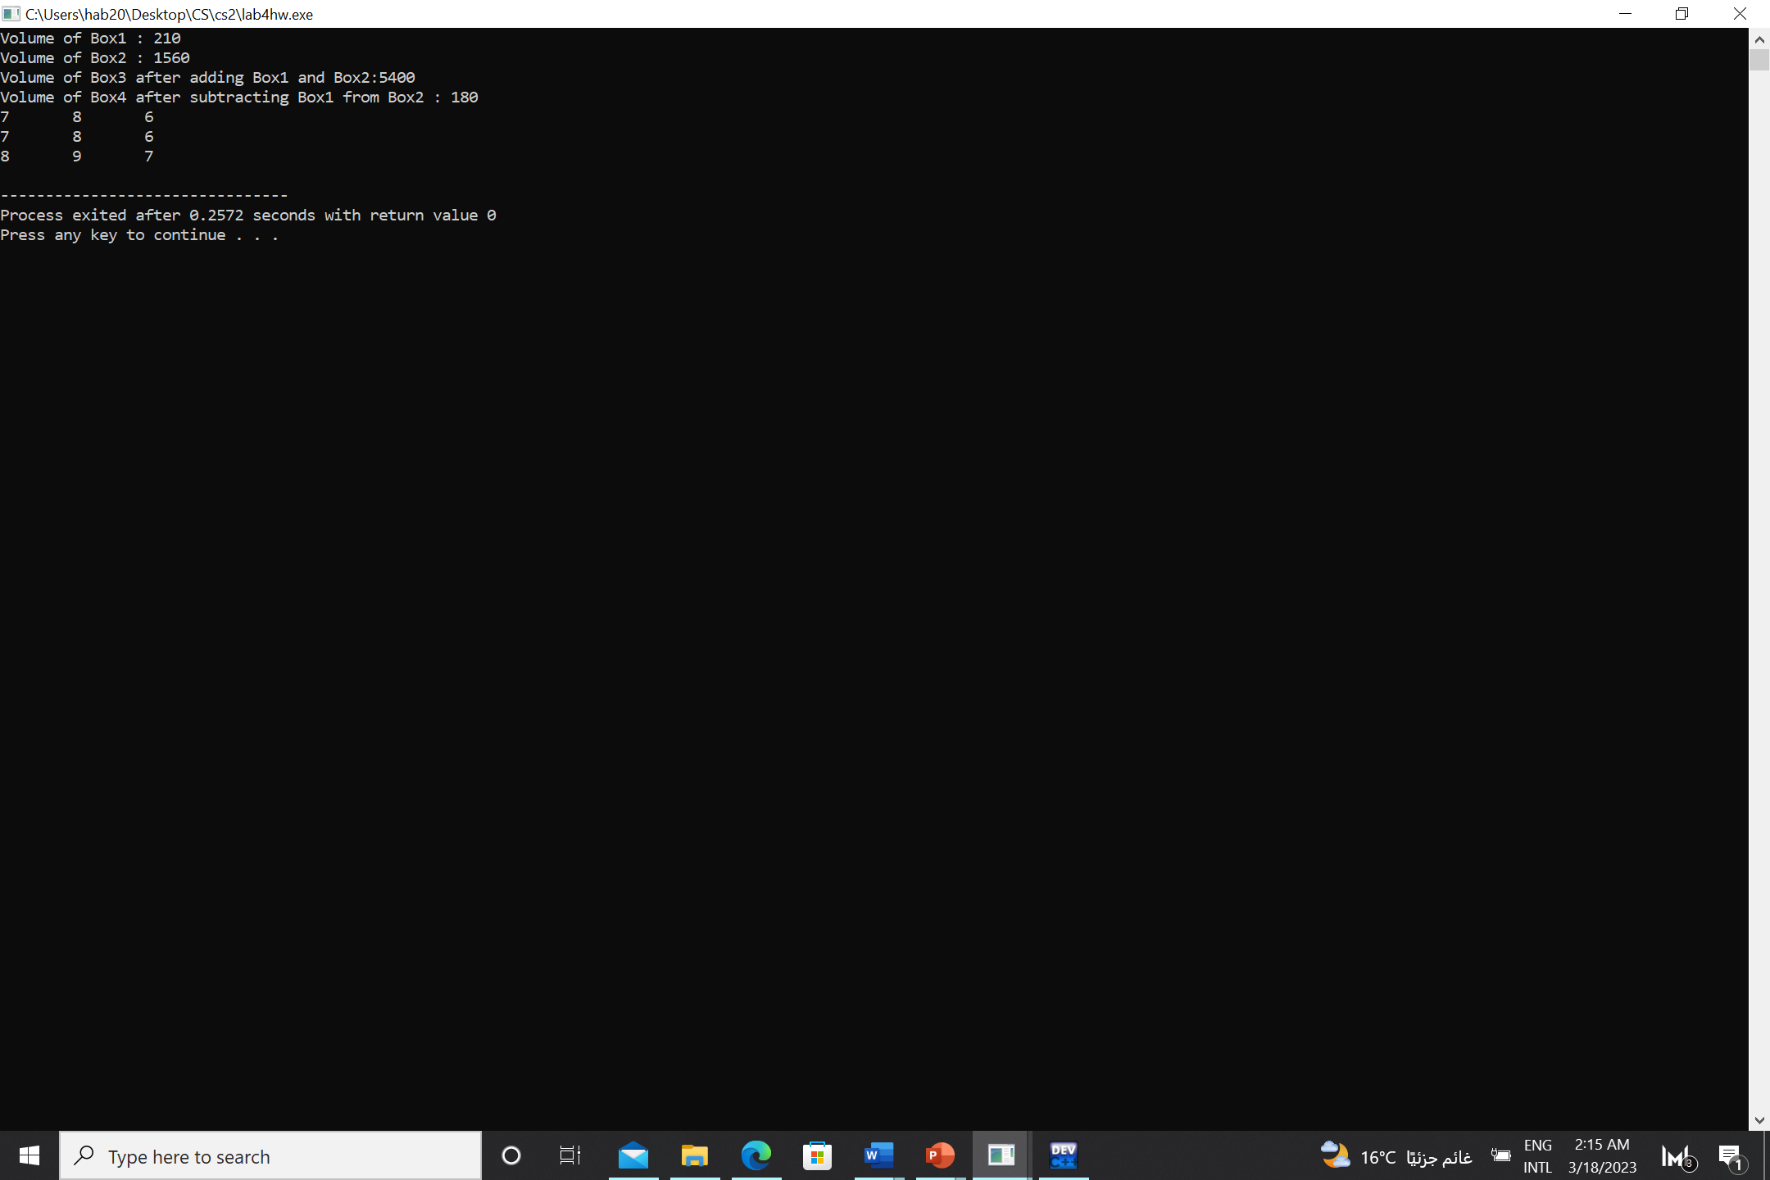

I assigned the incremented values to another object, k, and then incremented using postfix notation. I displayed the k to show that the value was assigned first and that the overloading for the postfix notation was done correctly.

Overloading prefix notation display (incremented by one from original)

This is the result of overloading the postfix notation (here I displayed the box object not the k) so the same object was incremented again but this time using a different overloaded function.